‘

**USER’S**

**MANUAL**

*Tracking Activity Project Management*

March 2023

|  |  |
| --- | --- |
|  | **User’s Manual**  **Authorization Memorandum** |

I have carefully assessed the User’s Manual for the Tracking Activity Project Management. This document has been completed in accordance with the requirements of the System Development Methodology.

MANAGEMENT CERTIFICATION - Please check the appropriate statement.

______ The document is accepted.

______ The document is accepted pending the changes noted.

______ The document is not accepted.

We fully accept the changes as needed improvements and authorize initiation of work to proceed. Based on our authority and judgment, the continued operation of this system is authorized.

_Noreen Keziah Sioco_____________ _____________________

NAME DATE

Project Leader

_______________________________ _____________________

NAME DATE

Operations Division Director

_______________________________ _____________________

NAME DATE

Program Area/Sponsor Representative

_______________________________ _____________________

NAME DATE

Program Area/Sponsor Director

**USER'S MANUAL**

**TABLE OF CONTENTS**

1.0 GENERAL INFORMATION 1-1

1.1 System Overview 1-1

1.2 Project References 1-2

1.3 Authorized Use Permission 1-2

1.4 Points of Contact 1-2

1.4.1 Help Desk 1-2

1.5 Acronyms and Abbreviations 1-2

2.0 SYSTEM SUMMARY 2-1

2.1 System Configuration 2-1

2.2 Data Flows 2-1

2.3 User Access Levels 2-1

2.4 Contingencies and Alternate Modes of Operation 2-1

3.0 GETTING STARTED 3-1

3.1 Logging On 3-1

3.2 Exit System 3-1

4.0 USING the SYSTEM (ONline) 4-1

4.1 Create Group Function 4-1

4.1.1 Edit Group Function 4-1

4.1.2 Delete Group Function 4-2

4.2 Add Project Updates Function 4-3

4.3 Add Task Function 4-4

4.3.1 Edit Task Function 4-5

4.4 Special Instructions for Error Correction 4-8

5.0 QUERying 5-1

5.1 Query Capabilities 5-1

5.2 Query Procedures 5-1

**1.0 GENERAL INFORMATION**

# GENERAL INFORMATION

## 1.1 System Overview

Explain in general terms the system and the purpose for which it is intended. The description shall include:

1. Major Functions of the system
2. Project Monitoring
3. Task tracking
4. Project task board
5. The system will be web-based and controlled by the admin (faculty, PDO, and teachers) given high access in the system, all the while the student are given medium access and will only be able to work at the project page they are invited to. all post and documents are to be saved in the systems server.
6. User access mode (graphical user interface)
7. admin - able to create and view projects and their progress.
8. student - able to post and comment all their works in their designated page
10. System name is (Tracking Activity and Project Management) TAPM
12. System code will be made by Laravel, Bootstrap syntax with PHP based framework.
14. System Category:
15. Major Application
16. System category:
17. *Major application:* performs clearly defined functions for which there is a readily identifiable security consideration and need.
18. *General support system* provides general ADP or network support for a variety of users and applications
19. Operational status:
20. Operational
21. Under development
22. Undergoing a major modification
23. General description
24. System environment or special conditions

## 1.2 Project References

|  |  |
| --- | --- |
| [1] | "Kissflow Inc.," 22 02 2022. [Online]. Available: https://kissflow.com/project/project-management-challenges/. [Accessed 29 April 2022]. |
| [2] | P. Fic, 2019. [Online]. Available: https://www.fnm.um.si/wp-content/uploads/2019/04/Dianoia_2019_1.pdf#page=15. [Accessed 29 April 2022]. |
| [3] | "Everhour," Everhour, 2015. [Online]. Available: https://everhour.com/blog/how-to-use-notion/#:~:text=You%20can%20call%20Notion%20a,art%2C%20and%20organize%20project%20details.. [Accessed 28 October 2022]. |
| [4] | "Microsoft 365," Microsoft, 26 January 2023. [Online]. Available: https://learn.microsoft.com/en-us/office365/servicedescriptions/project-online-service-description/microsoft-planner-service-description. [Accessed 15 november 2022]. |

## 1.3 Authorized Use Permission

TAPM is solely made for Asia Pacific College’s Project Development Office, in which targets to be used by the PDO’s students in regards to tracking their activities towards the Project Based Learning. The only authorized users of this system would only fall to APC’s management. Any unauthorized usage of this system, such as letting other schools, as well as selling it without the knowledge of the owner and developers of TAPM are strictly prohibited and will be punishable by the law.

## 1.4 Points of Contact

### 1.4.1 Help Desk

For any emergency or assistance towards the system, please contact Asia Pacific College and look for the Project Development Office.   
  
Phone Numbers:

* [+63 917 816 5570](tel:+63%202%20%2088529670)
* [+63 933 861 4227](tel:+63%202%20%2088529670)
* [+63 917 827 3243](tel:+63%202%20%2088529670)

## 1.5 Acronyms and Abbreviations

* TAPM – describes the name of the system which means *Tracking Activity Project Management*.
* APC – describes the name of the school which means *Asia Pacific College.*
* PDO – describes the type of user which means *Project Development Office*.

**2.0 SYSTEM SUMMARY**

# SYSTEM SUMMARY

## 2.1 System Configuration

As TAPM is a web application, its mostly revolve around the browser in which will be run in a web domain that will be managed by Asia Pacific College. As of the moment, the System is currently running in a Localhost with the help of XAMPP which is used for the database. The System will safely run in Windows 10 and any type of Browser.

## 2.2 Data Flows

As TAPM is running with the help of XAMPP. The XAMPP will be responsible on storing the database of the System in such a way of collecting the

## 2.3 User Access Levels

* Project Development Office (PDO) User Access – The Main User of the system. Can access the system freely in such a way to be able to use every possible function and feature within the system and has the privilege to change to Admin User, such as to see everything that has been created within the system.
* Faculty User Access:
  + Adviser User – A user of the system that holds authority in advising the students that it handles whereas, they can use the add task function in the system which will be giving direction into leading the students to properly manage their works at an outmost project-based reliance.
  + Teacher User – A user of the system that has authorities with watching over the students it holds. This user can manage the members that can have access over the group that has been made.
* Student User Access – A user of the system in which privileged to do update the other user on the project, as well as to manage the tasks that will be given.

## 2.4 Contingencies and Alternate Modes of Operation

Continuity of operations refers to an organization's ability to continue essential functions during and after a disaster, emergency, or accident. In the case of Asia Pacific College's PDO, continuity of operations involves reaching out to industry partners, assigning student project groups, monitoring project progress, and generating reports. However, if the Office 365 software used for project management experiences degraded performance, it could impact the office's critical functions. To address this, a proposed solution is to create a collaborative platform with additional features to improve project management and report generation capabilities. This would ensure that the office can continue its functions, even in the face of unexpected disruptions, with minimal interruption.

**3.0 GETTING STARTED**

# GETTING STARTED

## 3.1 Logging On

In logging in through the system, it is important to remember the user’s credential. In this case, the system will only require the user to use their APC credentials towards accessing the system. This way, users of the system will not be requiring to make different accounts.

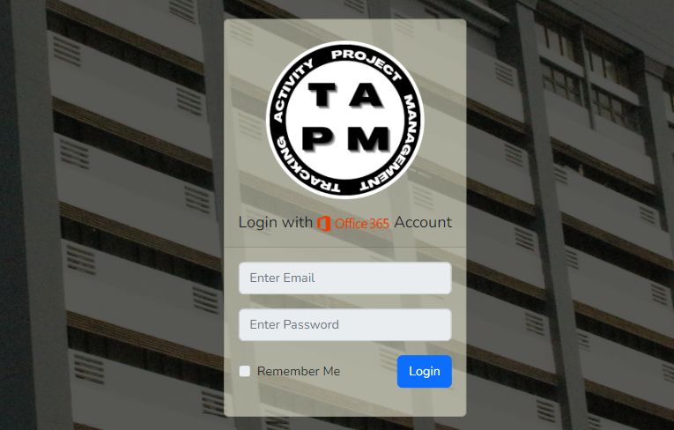

## 3.2 Exit System

In exiting the system. It is recommended to logout first with clicking the *Logout* button which will appear upon clicking the dropdown button at the top right section of the system, beside the user’s name.

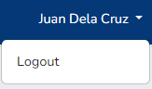

After such action, the user can safely exit through the web application with the click of the exit button at the browser.

**4.0 USING THE SYSTEM (ONLINE)**

# USING the SYSTEM (ONline)

## 4.1 Create Group Function

As of the moment, the user that has access to the said function will be the Project Development Office which will be in charge of maintaining the system. In this case, the PDO will have access to every group that has been created so far. To create one, the user only has to click the *Add Group* button in which will pop up a Modal where the user is prompt to enter details regarding the said group. The button will be found beside the user’s name.



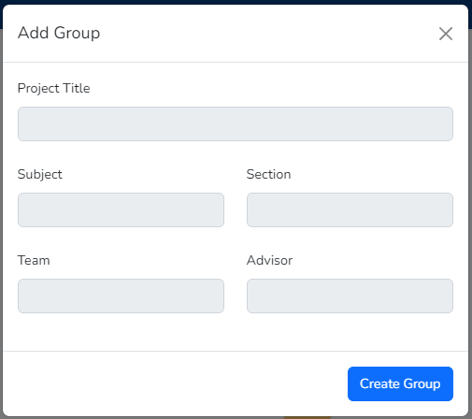

### 4.1.1 Edit Group Function

Upon creation of the Groups. User has an option towards the said group. One of the options is editing its content. To do so, just click the three-dot button that is on the top-right section of the Group Card. Upon clicking, shows a dropdown list of actions, which includes editing it. When clicked, it will show a pop-up modal of Editing Details in the said group card.

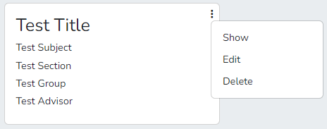

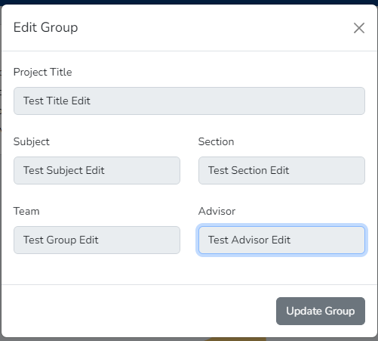

### 4.1.2 Delete Group Function

Another option that the user has is to delete the said group. This function works as the user clicks the *Delete* button at the dropdown list. Upon clicking, the user will be prompt to a pop-up modal that depicts if the user wants to delete the said group. If accepted, the group will be deleted out of the system.

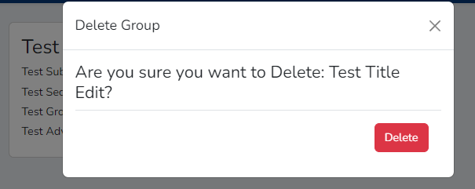

## 4.2 Add Project Updates Function

This function is a thing that a student user has access with. The purpose of this function is to update the other users regarding the project that has been made. To access it, user has to click the *Add Project* button at the Project page. This way, it will show a pop up modal regarding the contents to be filled in which the project should contain.

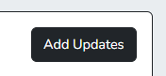

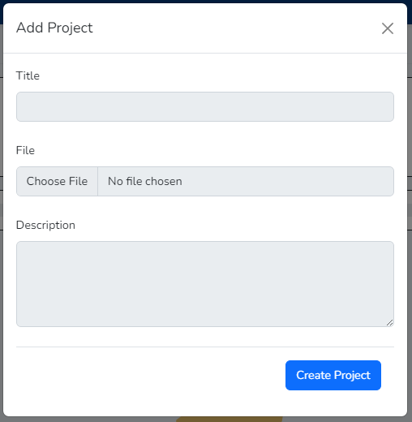

## 4.3 Add Task Function

This function focuses on letting the other users of what task should be done and be guided towards the development of the project. Every user has access to this except the teacher which only access is to view the progress of every groups. To use this function, user is prompt to click the *Add Task* button in which will reveal a pop-up modal of prompting the user to input the contents of the said task.

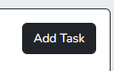

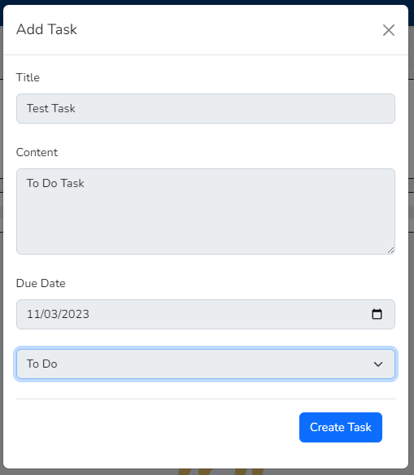

### 4.3.1 Edit Task Function

This function supports the Add Task function as the Task that has been made will not be forever to be in a *To Do* state, in which users that is responsible for the said task will be prompt to change the said task into the state that it should belong. To edit it, the user has to click at the *Edit* button at the top right section of the Task Card. After the action, the user will be prompt into entering content details that shall be edited.

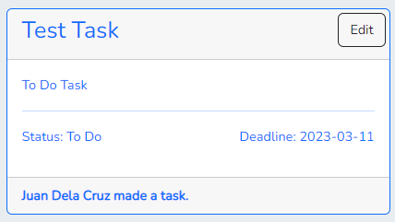

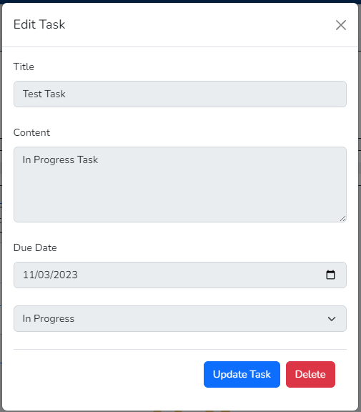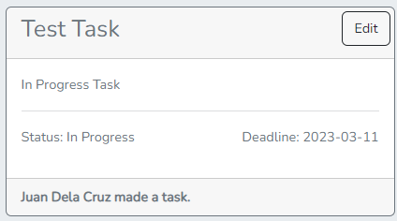

## 4.4 Special Instructions for Error Correction

The System will pop up some alerts that will be conveyed to the user in any case that the user has made a mistake in any create buttons. This errors mostly occurs when the user has an invalid prompt at the user input in declaring texts. This doesn’t mean that the user has broken the system but rather just feedback that the user has made a slight error and the message that will be derived will be the said error that occurred in the system.

**5.0 QUERYING**

# QUERying

## 5.1 Query Capabilities

As of the moment, to be able to run the system, it will require XAMPP, a computer program for compiling database that the system will be needing. With the help of Laravel framework, the query of data from the database will be easily understood.

## 5.2 Query Procedures

To be able to store data from the system to the database, a store function will be used. An example of it will be the query of validating the requested data when an admin wants to add another user to the system. This works in a way of fetching the user input and when submitted, will be saved to the database by accepting the created schema.,

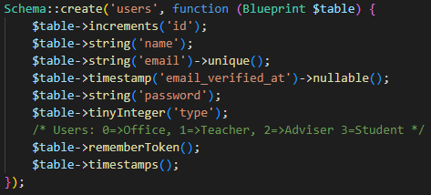

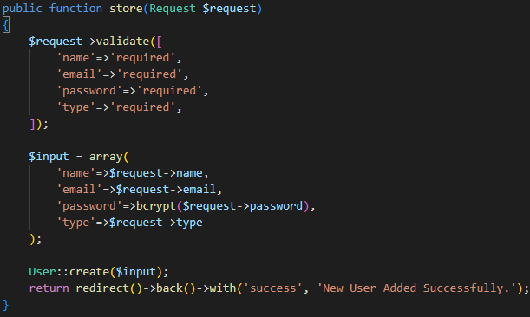

To be able to update the details of the data from the system to the database, an update function will be used. As an example, same procedures with the store data, the requested data will be validated through the user input and will be saved to the existing database of the same ID.

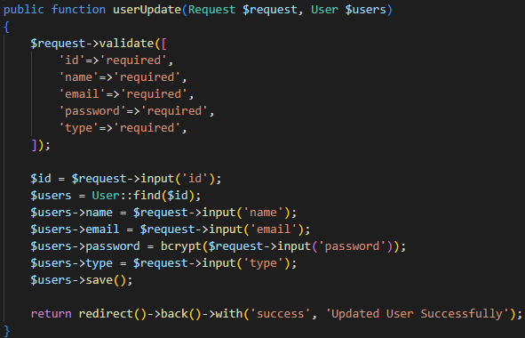

To be able to show the data that is already in the database, it will be fetching every possible data to the system by calling it to the system.

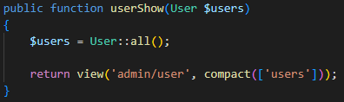

To be able to destroy the data from the database, the query will be fetching the ID of the said data and will be validated in order to deleted the requested data.

